MARIE SUMMARY SHEET
POWERS OF 2

1 2 9 512 17 131072
2 4 10 1024 18 262144
3 8 11 2048 19 524288
4 16 12 4096 20 1048576

5 32 13 8192 -1 .5
6 64 14 16384 -2 .25
7 128 15 32768 -3 .125
8 256 16 65536 -4 .0625

MICROCODE FOR MARIE
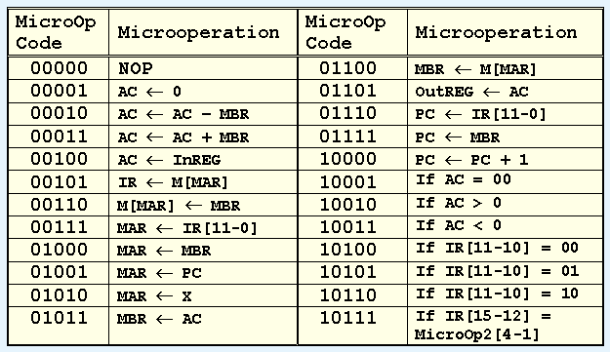

11000 MBR <- PC
11001 MBR <- X
11010 AC <- 1
11011 PC <- AC
11100 AC <- MBR
Do not use 00111.

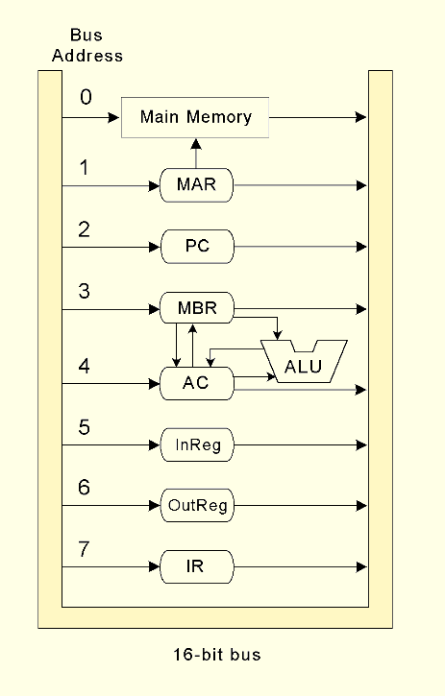

SIMPLIFIED RTL FOR MARIE

JNS (0):  MBR <- PC  MAR <- X  M[MAR]<- MBR  MBR <- X  AC <- 1  AC <- AC + MBR  PC <- AC  LOAD (1):  MAR <- X  MBR <- M[MAR]  AC <- MBR  STORE (2):  MAR <- X  MBR <- AC  M[MAR]<- MBR  ADD (3):  MAR <- X  MBR <- M[MAR]  AC <- AC + MBR  SUBT (4):  MAR <- X  MBR <- M[MAR]  AC <- AC - MBR  INPUT (5):  AC <- InREG  OUTPUT (6):  OutREG <- AC | HALT (7):  (no operations needed)  SKIPCOND (8):  If IR[11 - 10] = 00 then  If AC < 0 then PC <- PC + 1  else If IR[11 - 10] = 01 then  If AC = 0 then PC <- PC + 1  else If IR[11 - 10] = 10 then  If AC > 0 then PC <- PC + 1  JUMP (9):  PC <- IR [11-0]  CLEAR (A):  AC <- 0  ADDI (B):  MAR <- X  MBR <- M[MAR]  MAR <- MBR  MBR <- M[MAR]  AC <- AC + MBR  JUMPI (C):  MAR <- X  MBR <- M[MAR]  PC <- MBR

